Animal Cop Final Report

# Overview

## Executive Summary

This semester, our team of BHCI students worked with the Humane Animal Rescue shelter to design a solution that simplifies the animal abuse reporting and investigation process. As a result, we created Animal Cop which is comprised of a digital reporting form for concerned citizens and a management application for humane officers. In this report, we present our final design solution. In addition, we provide a high level overview of the semester-long design and research process that led to this final solution.

## Client Background

In January 2017, Pittsburgh’s Animal Rescue League (ARL) and Western Pennsylvania Humane Society (WPHS) merged to form Humane Animal Rescue (HAR) -- one of the largest open-door shelter in Pennsylvania. Our clients hope to better promote animal welfare by expanding their humane investigations department and exploring technological solutions to support their new Humane Police Officer (HO) . Humane officers conduct a variety of investigations animal including neglect, hoarding, cruelty, and even dog fighting operations. They are responsible for preventing, intervening, and prosecuting these cases.

Simultaneously, humane investigations require input from the public. Concerned citizens send reports of animal abuse to the HO for investigation. However, “humane investigations are complicated in Pennsylvania, and especially in Pittsburgh. Depending on the situation, federal, state, county and municipal laws may need to be enforced by different agencies with sometimes overlapping responsibilities, including police and municipal animal control employees in addition to Humane officers. Concerned, well-meaning citizens inevitably get confused, often contact the wrong authority, too late, and without the necessary evidence, which can prevent officers from taking action and successfully prosecuting criminal cases.”

## Client Need

In order to help the Humane Animal Rescue shelter provide better humane investigation services and help the community, our client would like to introduce a computer-based system that supports

1. residents in reporting possible abuse
2. the shelter’s new HO in managing those cases and interacting with other agencies
3. Staff who work with animals that may been subject to abuse and who interact with potential offenders and witnesses during intake and adoptions.

# Final Design Overview & Design Goals

Our final solution is comprised of a citizen facing reporter form and an HO facing management application.

Reporting Form

Main Features:

* Collects accuraMitigates the emergence of false reporting
* te information from reporters and convey it to staff/HOs
* Educates reporters about the role of an HO, animal laws, and the investigation process
* Provides feedback to users after reporting (unimplemented due to time constraints)

[Insert pretty images of our prototype here! Screenshots of each item with a name and labels showing how you progress through the screens]

HO Tool Form

Main Features:

* breaks down and analyzes information from citizen reports
* organize the reports based on severity and priority.
* provides location information, creating a map with cases in the itinerary as well as new and in progress cases

[Insert pretty images here]

Marketing Materials

We created materials for the client to promote this solution in the future. Another sentence about why we did this?

[insert image of poster and postcards here!]

# Process Work

To reach our final solution, we worked through several key phases. We began with background research. Our next phase was ideation. We then proceeded to iteratively develop prototypes, starting with lo-fi paper prototypes and finally ended with our deliverable.

## Research

### Hunt Statement

We aimed to design a solution that simplifies the humane investigation reporting process for both concerned citizens and staff at for the Humane Animal Rescue shelter. To reach this solution, we aimed to explore the current obstacles and incentives for citizens to recognize and report animal abuse, as well as understand the current animal rescue process as conducted by the Pittsburgh animal rescue community. Additionally, we aimed to identify the key pain points humane officers and face in investigating and managing humane cases.

### Research Overview

In our research, we aimed to understand the current process of reporting and investigating humane cases to identify opportunities for the Humane Animal Rescue shelter to improve their humane services. In order to gain a better understanding of the problem space we conducted a literature review, competitive analysis, contextual inquiry, an expert/stakeholder interviews. We distilled our insights from this research by creating affinity diagramming constructing different conceptual models such as service blueprints, cultural models, and user flows.

#### Literature Review

Since there were no direct technological competitors for us to examine in regards to our project, we decided to dive deep into five separate topics to gain knowledge that may be relevant to our project: PA Animal Cruelty Laws, Child Abuse, Citizen Science, Municipal Reporting, and Bystander Intervention.

**PA Animal Cruelty Laws**

Animal cruelty legislation exists both on the state and county level. This leads to complications such as contradicting regulations and ambiguity across county lines. Animal Cruelty laws also differentiate between more severe criminal offenses and less severe fines. Ultimately, humane officers serve as deputizes law officers that enforce these cruelty laws and identify where a case falls on this spectrum. However, when actually investigating a case, humane officers are not permitted to enter private residences without permission or a search warrant. Likewise, they cannot seize animals without proper cause.

Ultimately, an analysis of PA Animal Cruelty Laws demonstrates how current laws and regulations are complicated. While this literature gives us a clearer understanding of what legally constitutes animal cruelty and humane officer responsibilities, it highlights how citizens need an understanding of a complex legal system to truly understand what actually constitutes as animal abuse.

**Child Abuse**

We looked into ways technology is utilized to handle child abuse cases. The main function was to take and store client notes. In some cases, the implementation of technology has changed the way in which social workers interact with clients. A few social workers have started implementing FaceTime and Skype to conduct counseling sessions.

In instances of child abuse, there is often collaboration with different organizations (police, hospitals, lawyers). There is a strong need for efficiency in broadly disseminating information internally and externally. To serve these need of organizing and sharing resources, some social workers utilize systems such as Google Drive, Slack, or Trello. Through our research, we also found that technology was very useful in business operations and management such as monitoring personnel, creating programs, communicating with professional orgs, government entities, stakeholders, and employees.

The largest pain point that social workers expressed was not being able to connect to important client data and information when they are outside of the office visiting a client. They often had to rely on only the documents they brought with them at the time.

**Citizen Science**

Citizen science, also known as crowd science or crowd-sourced science, is defined as scientific research conducted, in whole or in part, by amateur or nonprofessional scientists. Technology is credited as one of the main drivers of the recent explosion of citizen science activity, where public participation in scientific research has increased significantly. Although citizen scientists are passionate and eager to help, there are definite limitations on the validity of volunteer-generated data, where volunteers can lack proper training in research and introduce bias into the data, or even lie about the data in order to get a promised reward for the task. We were unable to find any existing citizen science projects specifically geared toward animal abuse, but there is evidence that crowdsourcing has helped crime investigations in the past few years and therefore points to potential success in using crowdsourcing to help animal abuse investigations.

**Municipal Reporting**

The City of Pittsburgh has a [311 Response Center](http://www.pittsburghpa.gov/311/form) that utilizes various different forms of technology to make reporting non-emergency issues easier for residents. Using the “MyBurgh” mobile application, users can submit a report with an optional photo and/or GPS location and receive status updates as the job is completed. With the application, users can report issues such as graffiti, potholes, missed garbage pickup, and overgrown grass. Other ways for residents to get in touch with the city’s 311 Response Center are via live operators on their phone line, via text message, via TeleTYpewriter (TTY) line, via Twitter, and via a web form. Users can submit reports anonymously if they do not require a response, and all service requests sent with a valid email address with be provided a ticket number and possibly a service request ID number. One interesting factor is that in the types of issue that users may select on the mobile application and the web form, “animal issues” such as animal waste, check conditions, dead animal, loose dogs, and rodent control are included on the list. However, it seems that these reports filed to the 311 Response Center will go directly to the Pittsburgh’s [Animal Care & Control](http://pittsburghpa.gov/animalcontrol/) office, and not to shelters around the city.

The existing web form and “MyBurgh” mobile application seem fairly robust but it is unclear how many users they have and whether or not they are actually helping users feel better about reporting issues to be resolved quickly. These existing technologies may prove helpful for our project as we may use them to help us conduct usability research and pinpoint problems with the current reporting mechanism and places for our team to ideate and improve upon.

**Bystander Intervention**

We looked into research concerning the bystander effect in order to understand on a psychological level how citizens may be de-incentivized to report or respond to animal abuse.The bystander effect is a well-studied psychological phenomenon wherein individuals observing a case of abuse/violence/emergency are less likely to help the victim if others are present, such that the likelihood of help is inversely related to the number of bystanders. Latane and Darley’s (1970) 5-stage model breaks down the sequence of intervention into 5 concrete steps, which also illuminates the moments when breakdowns can occur and a bystander chooses inaction. A bystander must:

1. *Notice the event*
2. *Recognize it as an emergency*
3. *Take responsibility*
4. *Know/decide how to respond*
5. *Have the confidence to respond*

In the event that we choose to target citizen awareness and response, we can use this model as a foundation for identifying and focusing on moments in the reporting process when breakdowns are most likely to occur.

#### Contextual Inquiry & Expert Interviews

To gather rich data about the current animal rescue process, we interviewed experts in the process and used contextual inquiry methods. Our interviews employed some guiding questions that would lead to more in-depth recounting of experiences. The contextual inquiry method involved more immersion in the actual processes of ARL by observation and in-the-moment questions.

Populations:

Humane Officer/Shelter Staff

Pittsburgh Animal Control

Wildlife Officer

Community Members

#### Expert Interviews

### Research Insights

*INSIGHT 1:* The main goal of animal rescue is to educate, not confiscate

One piece of information we heard repeatedly is that a humane officer’s primary role is to educate by giving people the resources necessary to care for their animals. Actually taking the animal away is always considered a “last resort” type of situation. Debbie, Lois, and Rachel all highlighted cases where they gave as many resources to the animal owner as possible, rather than immediately taking the animal. We also learned that animals are property under law, and that they can only be surrendered willingly by an owner or seized with a warrant. This further emphasizes the importance of developing cooperative relationships with owners and taking an educational role when possible.

Opportunities:

* Create tool to aid humane officers in educating citizens quickly and effectively.
* Facilitate shared decision making process between Humane Officer and citizens to empower them to find ways to improve the situation.

*INSIGHT 2:* Laws are complicated and don’t match people’s assumptions

There are currently several levels of laws (national, state, county, municipal) regarding animal welfare. Laws also apply differently to different species of animals. Because citizens don’t know what legally constitutes animal abuse, they will make complaints that do not fall under animal cruelty law. Furthermore, people don’t understand which legal responsibilities fall under which agencies. This leads to citizens reporting to the wrong agency. In some cases, they don’t even know that humane officers exist specifically to deal with humane investigations. When citizens’ misunderstanding of laws impacts their reporting behaviors, valuable time and resources are wasted for all parties involved.

Citizens may take it upon themselves to remedy situations they perceive to be animal abuse, sometimes in illegal ways. Interviews with Lois and Rachel revealed that there are many cases where individuals see animals and take the animal from their owner. Because animals are legally considered property in PA, this type of action is illegal despite the citizen’s good intentions. When well-meaning citizens are told that what they are doing is illegal, we learned that they feel disappointed and let down. Furthermore, our interviewees revealed that negative emotions can arise when citizens want humane officers to make actions that are beyond their legal jurisdiction. While citizens assume that humane officers can immediately seize animals out of a bad situation, they become disappointed when humane officers must deal with legal protocols before proceeding.

Opportunities:

* Help collect necessary information needed from reporters to improve humane officer’s understanding about the severity of the case and whether it constitutes as animal abuse.

*INSIGHT 3:* Animal rescue is like social work; it involves people, not just animals.

A recurring theme from our interviews is that people, and social work, is an integral part of animal abuse cases. One notable finding is that animal abuse can occur due to altercations between people - a domestic incident can result in the harm of a pet, for example. Humane officers need to work closely with owners to provide solutions for both the people and animals involved. Furthermore, false reporting can also be a direct consequence of animosity between neighbors, or a targeted attack against an individual. Social behavior cannot be taken out of the equation when thinking about animal rescue.

Opportunities:

* Facilitate better communication and methods for humane officers to follow up with animal owners

*INSIGHT 4:* Animal rescue operations are collaborative and co-dependent.

In conducting interviews with various stakeholder, we learned that sometimes cases aren’t a matter of just animal abuse. Instances of animal abuse can co-occur with other crimes and violations that necessitate continued investigation by and communication between various agencies. Ultimately, overlapping jurisdiction over cases require various agencies including Animal Control, humane officers, and Pittsburgh Police to work together to investigate cases. In general, communication between these parties are mediated by simple technologies: phone calls and email. Furthermore, most cases are processed and managed with paperwork rather than technology.

Considering the collaborative nature of animal rescue operations, communication and cooperation breakdowns points have serious effects on the way that investigations are carried out. We discovered one particular breakdown between humane officers and Pittsburgh Police. HOs rely heavily on police to actually make arrests and attain warrants. However, interviews revealed that police are sometimes unwilling to dedicate adequate time and resources into humane investigations. Ultimately, Pittsburgh Police and humane officers have different priorities when it comes to investigations. This difference leads to problems. Ultimately, these type of breakdowns will be important to consider when going forward.

Opportunities:

* Support clear shared information and evidence gathering across organizations and stakeholders.
* Design for multiple types of users with differentiated access and control at stages of the process.

*INSIGHT 5:* Misreporting can have serious consequences for the organization, people, and animals involved.

Humane Officers and Animal Shelters have few resources in dealing with a high volume of daily cases. When a report comes in, the HO cannot rely on potentially bias reporters to accurately and truthfully describe the situation, therefore in most cases they need to make a site visit to assess the situation fully. At this point, HO’s must evaluate the severity (emergency vs. non emergency) of the situation, and the willingness and ability for the accused to be cooperative. This can be highly stressful and high pressure, as they are in the state of constantly attempting to maximize their resources towards the most severe, life threatening situations, with minimal information at hand. Misreporting can be a serious drain on the resources of the HO to do their job.

Opportunities:

* Support education on what constitutes animal abuse.
* Increase difficulty for people to false report
* Give reporters tools to provide more valuable tools to collect evidence that will help HOs determine abuse before a visit.

*INSIGHT 6:* For citizen reporters, lack of feedback after reporting is frustrating and disheartening.

Community members who report animal abuse are often emotionally attached and wish to be updated on the status of the animal and investigation, but there seems to be no current mechanism to allow follow-ups on animal abuse cases after they are opened. As a result, citizens become “concerned that nothing is being done”. Citizen reporters may attempt to get updates from the shelter or humane officer multiple times to no avail, become disheartened, and possibly discouraged from reporting cases in the future. Citizens strive to understand whether their actions have actually impacted the situation.

Opportunities:

* Enable clear communication back to citizens through a more transparent tracking/numbering system for animal abuse cases.
* Keep citizens in the loop through automatic updates for reporters of animal abuse cases.

## Ideation

We used our insights to guide our initial ideation process and reimagine a future that addresses the implied problems. We began our ideation process by collaboratively brainstorming with our clients and then group visioning as a team. We created storyboards to outline each idea, and then speed dated them with stakeholders and potential users. These storyboards acted as early prototypes of our ideas, and we were able to identify design ideas that were most worthwhile to pursue based on feasibility and importance.

### Ideation Process

#### Client Brainstorming

We worked collaboratively with our clients, using a design challenge to remove assumptions about what does happen in order to encourage them to imagine what could happen. Through this exercise, we generated a wide variety of imagined futures and specific design ideas for possible implementation, from which we chose a six interesting ideas to flesh out in greater depth.

#### Group Visioning

We conducting group visioning to explore the user experience through each idea.

#### Storyboarding

We outline 2-3 different versions for each broad idea (18 storyboards total)

#### Speed Dating

Then we “speed dated” the storyboards with our clients, shelter staff and citizen, collecting feedback on aspects that they liked/disliked, and whether they could see themselves using the idea.

### Ideation Insights

#### 

## Lo-Fi Prototyping

### Citizen Reporter Side

The reporter side of the interface is designed for citizens with any level of experience reporting animal abuse. The goal is for this interface to be its own separate website that can be accessed from the main shelter site. In order to test this design, we talked to students, friends, and acquaintances that may or may not have any experience with reporting animal-related incidents.

We created a low-fidelity prototype using Google Forms and paper pop ups, which included main question types, which include the personal information of the reporter, the time/location of the incident, and the description of the animal(s) involved. The goal of this iteration was to consider the types of questions that would appear on the form and to evaluate whether the content and framing of these questions was appropriate.

### HO Side

For the humane officer interface, we created our first paper prototype around the scenario of a humane officer who receives an incoming report and is able to add it to their itinerary of cases to investigate for the day.

## Mid-Fi Prototyping

### Citizen Reporter Side

For the second iteration, we built the actual website using the Materialize CSS framework which allowed some more flexibility in how we structured our questions and input fields. To evaluate both versions, we recruited participants from around CMU with little to no reporting experience and asked them to imagine themselves in different scenarios involving animal cruelty and neglect.

### HO Side

Based off of feedback from our paper prototype, we created a second prototype in Axure to mock up interactivity. This prototype was tested with an ARL/WPHS staff member who had previous humane officer experience to ensure the prototype matched the workflow of the Human Officer. We also tested the usability of the prototype with other individuals using simple task analysis.

## Feature Iteration

### Reporter Side

#### Header

One problem we learned through research was that citizens don’t really understand what it means to report animal abuse/ neglect, some utilize animal-abuse reports maliciously to harass neighbors, exes, etc while others don’t trust that anything happens.

**Iteration 1 : Google Form**

Our original focus for the header was to inform citizens in the most direct way possible that deliberate false reporting can have serious consequences.

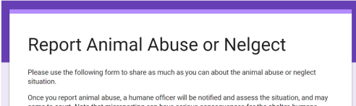

**Iteration 2:**

After some testing, we also realized that this space could be used to inform reporters about the sequence of events that would occur after reporting. We also saw this opportunity as a way to educate citizens about what an HO does. We included the “How this form is used” link, which would link to a second page that describes in more detail the workflow of the HO and contextualizes and humanizes the process of reporting.

Another change we made early on was to change the title of the page from “Report Animal Abuse or Neglect” to “Report Animal Neglect and Cruelty.” From our research, “abuse” is perceived to be a term with strong connotations that can be immediately off-putting if a reporter is unsure about what constitutes animal abuse. We realized that the header design was an opportunity to address the biases that users bring to the form.

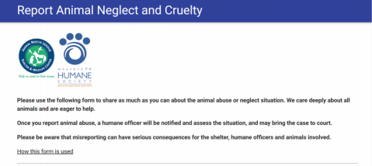

**Iteration 3**

We decided to create a graphic that illustrated the important information reporters needed to know before they filled out the form. This included things such as only reporting to one agency if you are in allegheny county and a first hand witness. These are the most common issues the Animal Shelter dealt with in regards to reporting and often delayed the process. As we know that many users did not like to read text, we used the graphics to grab their attention towards the important information.

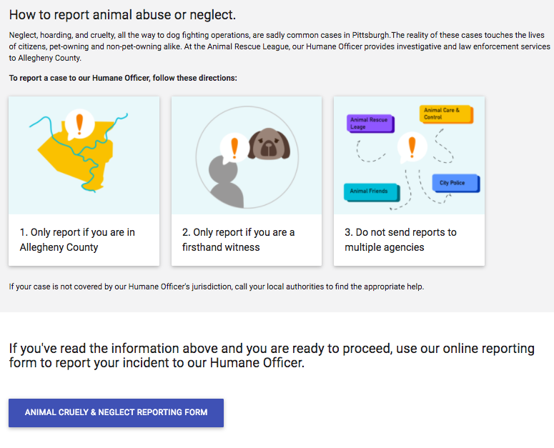

#### Location/Time of Incident

**Iteration 1 : Google Form**

From testing we saw that users sometimes had trouble pinpointing a specific address and wanted to know what they could do if they only knew the street name or neighborhood of the incident

In addition, users often had trouble pinpointing a specific date and time of incident and experienced confusion when the incident was ongoing.

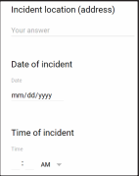

**Iteration 2:**

As a result of testing iteration 1, we implemented the Google Maps API with a map and autocomplete function in the second iteration of our prototype in order to solve the problem of not knowing the specific address.

We added a checkbox to the second iteration of the prototype in order to allow users to indicate ongoing incidents as well as some help text to ask the user to provide the last time they witnessed the incident, even if it is an ongoing incident.

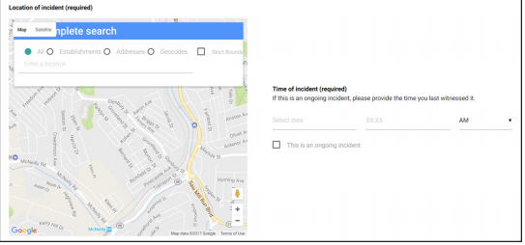

Type of Incident / Critical Indicators

One of the major goals of the citizen reporting system is to educate citizens on what is and

isn’t legal with regards to animals, since we found from testing that a majority of people

do not understand or even know about the laws in place currently. The laws are also quite

complicated so we are attempting to explain them in plain English as a part of the form.

**Iteration 1 : Google Form**

In our first iteration, we used paper “pop ups” that would appear on the screen when the user wanted to “click for info” next to some of the types of incidents. They provided explanations for each law and even directed citizens to their local representatives if they were unhappy and wanted to reach out to them in an attempt to change policies. However, many users during testing were confused about how the pop ups worked and/or missed seeing them on the form so did not attempt to click for more information.

We also received feedback from shelter staff that incidents involving dangerous animals, theft,

and stray animals are actually handled by City of Pittsburgh’s Animal Control and should be

directed there instead.

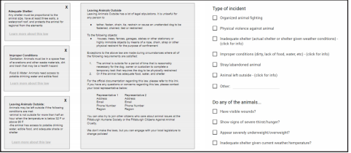

**Iteration 2:**

To solve the problem of misreporting cases intended for Animal Control to this application, we added information to the help text indicating the incidents in which to report to Animal Control instead.

We also added blue “learn more” buttons next to each type of incident to help them stand out more, and included accordion-styled boxes with the educational information that appear below each incident type, providing a less jarring interaction for users than actual pop ups on the website. In addition, we decided to remove the “appear severely underweight/ overweight” option as one of the critical condition indicators due to feedback that it was sometimes difficult to tell what the normal weight for an animal is, and that weight could already be inferred from the choice of “an animal showing signs of severe hunger/thirst”.

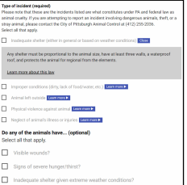

**Iteration 3:**

In order to test the effectiveness of the alert we gave users scenarios that dealt with cases covered by the human officer or animal control. We asked them to walk through the reporting process based on the scenario. From our testing, we saw that many users were unaware of what to do when the scenario was not covered by the options shown and they did not read the help text that said to contact animal control. In order to solve this problem we created another version that had a large callout with a question mark that took reporters to another page if what they wanted was not on their list. This new page listed other possible scenarios they might want to report and reporters can see who to contact for each scenario by selecting the “what is this?” button.

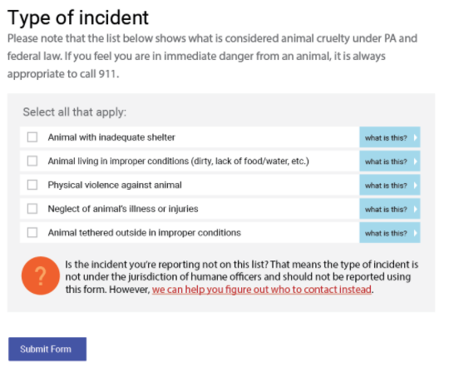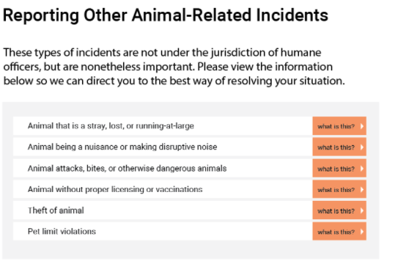

**Iteration 4**:

From our testing we found that even though the question mark was bold and large indicating people where to go if what they wanted was not given on their list, there were still some reporters that did not read or notice it and were still confused about what to do. For those users that did make it to the next page, some became confused when they saw the scenario they wanted to report but did not know how to find out who to contact. Many users were used to the previous’ page use of checkbox to select the correct answer but this new page did not have checkboxes and users were not inclined to select the “what is this?” which contained the information they needed.

Based on this insight, we decided to maintain the action that users are familiar with, which was selecting the boxes for their desired option. As a result, we took away the question mark section at the bottom of the page and added an “Other” section. When they click “Next”, they will be taken to the next page which contains the list of other possible scenarios. On this page, reporters now have the option to select the option they are trying to report and the accordion will unfold to show in large and bold font who to call, as to grab the user’s attention.

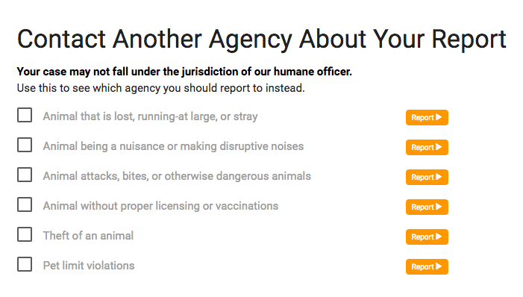

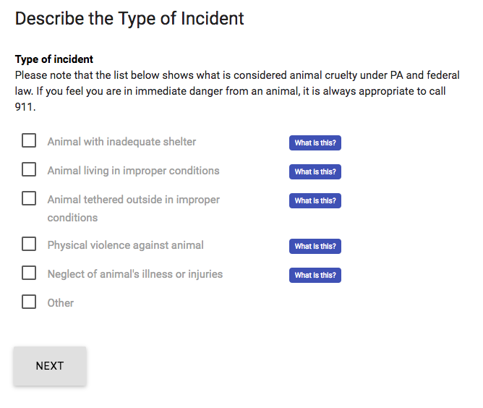

### HO Side

#### Map

**Iteration 1 :**

In our first iteration, the only information included in each case was the address and a

single line categorical description of the incident.

(map).

**Iteration 2:**

In the second iteration, we added a map overview of the planned trip and a button to allow the HO to start the trip and enter the GPS.

#### Itinerary / Backlog

**Iteration 1 :**

All cases that enter the system are placed on the “Backlog” list. When the HO wants to plan which cases they want to attend to for the day, they are able to drag the cases from the “Backlog” and into the “Itinerary”.

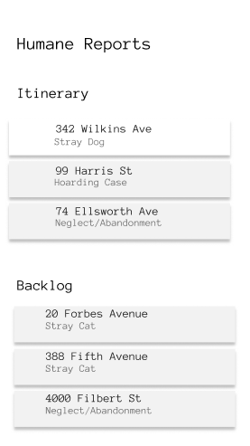

Low-Fidelity: Itinerary and Backlog

**Iteration 2:**

We added tags for cases that were urgent. This provide an indication to the HO as well as assist in which cases to prioritize. We also added indications on the right of each case that showed that they were draggable.

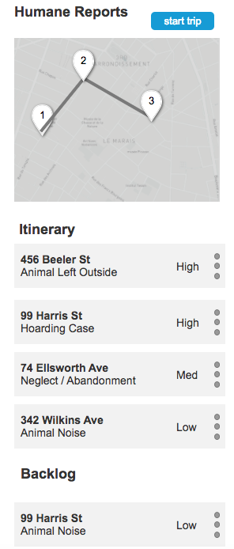Iteration 1: Urgency Tags

**Iteration 3:**

From testing we found that it would be easier for the HO when prioritizing and looking through the itinerary and backlog by toggling between each, instead of having both on one page and scrolling up and down.

For each case in the itinerary and backlog, we added the number of days since the incident was reported. This will help the HO better prioritize cases to attend to first. We also added a “plus” symbol to cases in the backlog so that HOs can add them to their itinerary. An “x” symbol was added to cases in the itinerary so they can be removed and returned to the backlog.

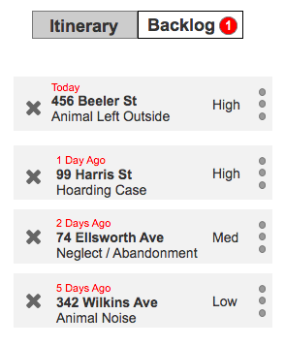Iteration 2: Days since report

**Iteration 4:**

We decided to further divide the itinerary/backlog into three sections: Itinerary, New, and In Progress. All new cases from the reporting system will be kept in the “New” section. The cases that the HO plans on visiting that day will be placed inside “Itinerary” by the HO. The “In Progress” section will contain cases that the HO has visited but must go back to follow up before closing the case. We decided to change the label of this section from “Backlog” to “In Progress” in order to use wording that was familiar to the HO and not too technical.

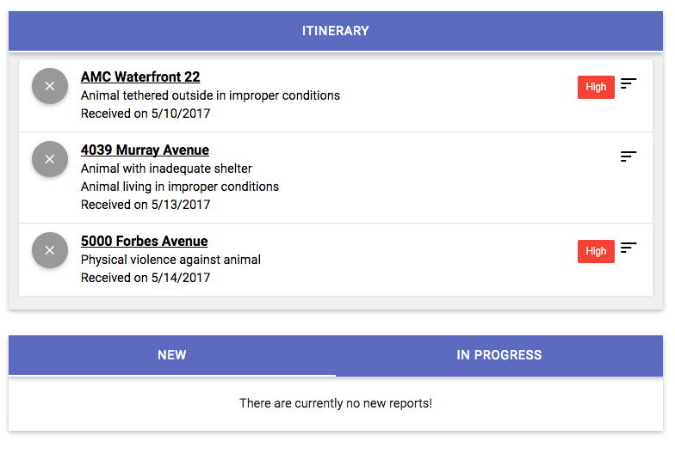

#### Review Report and Add Notes

Once the HO has arrived at the scene of the investigation, they have two needs: 1.) Quick

reference to as much information as possible, 2.) Ability to easily add new information

and evidence into the report.

**Iteration 1 :**

By clicking a case that is on the Dashboard, HOs are able to reference the initial report as well as add additional information they obtained from their visit and is necessary for to be recorded.

The HO can add notes, rate the condition of the animal, rate the urgency of the case, and attach pictures.

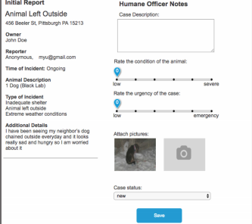

**Iteration 2 :**

From testing iteration 1 with HOs we learned that there is no clear guideline of what information is necessary for HOs to record when visiting a location. In order to standardize this process and make sure that all necessary information was collected, we provided more structure to the notes section and provided fields for all necessary information. To account for instances of where there is more than one animal, we added “Add Animal” button that leads to a form that HOs can fill out for each animal. In order to account for follow-up visits and updates, we added an “add note” button that HOs can fill out and also tracks the date the note was made.

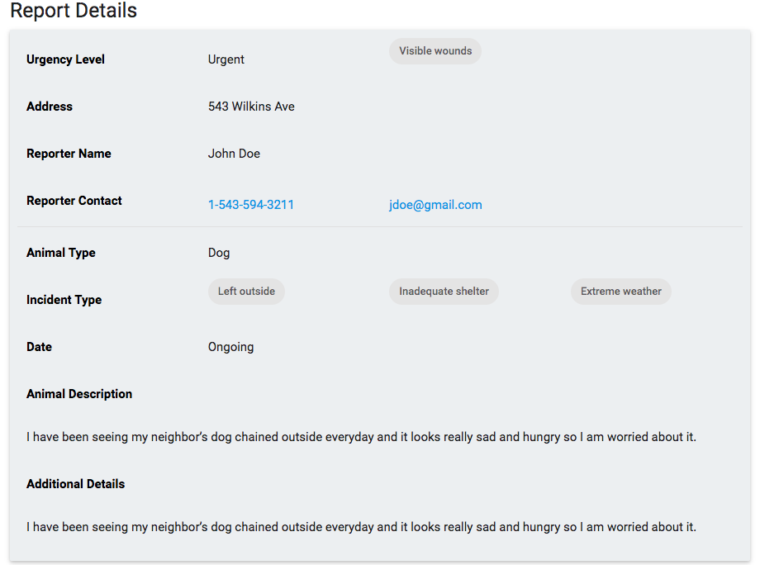

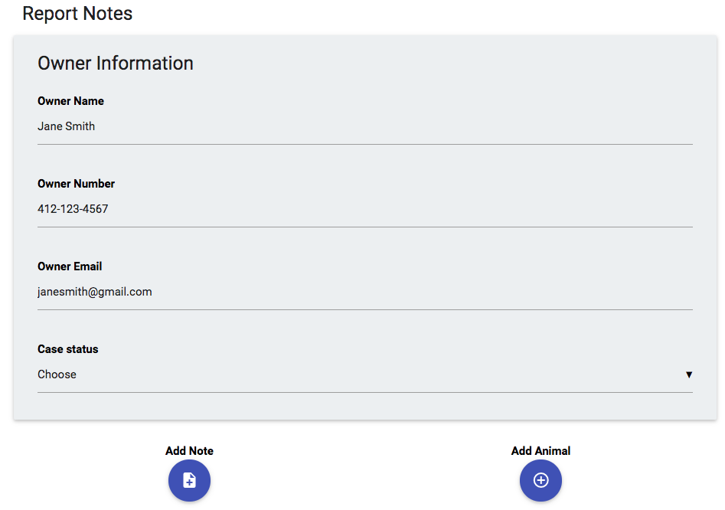

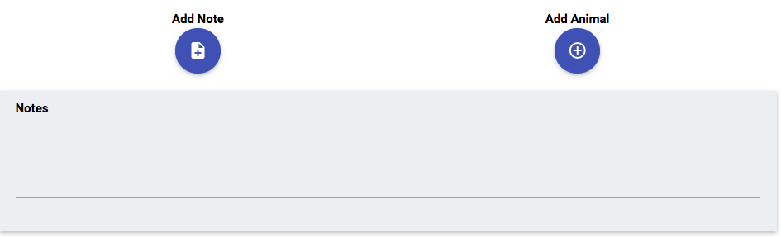

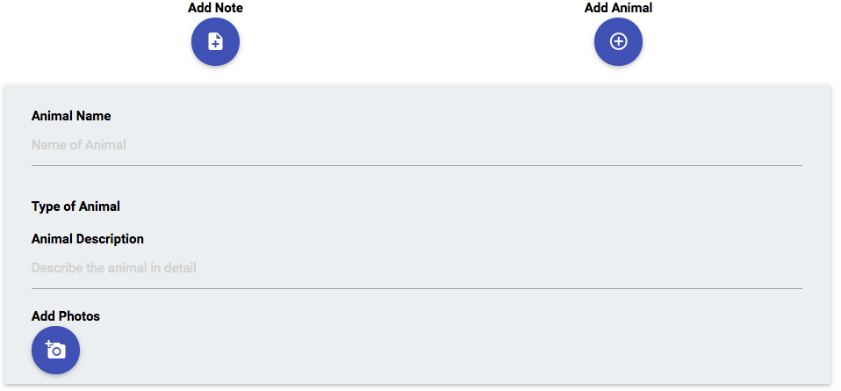

#### Close Case / Send Notice

Once the HO marks the case as “closed” in the application an automatic email update is

sent to the reporter, if they opted into receiving updates from the case. This e-mail thanks

the reporter and informs them they their report has been investigated.

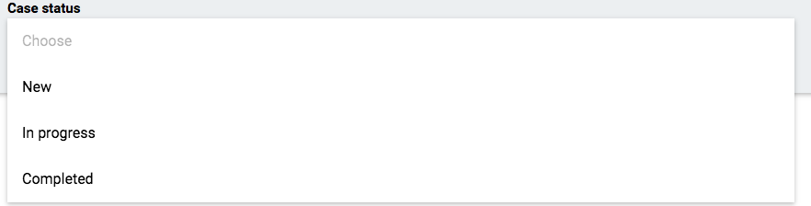

Archived Cases

To account for instances when HOs may need to reference past cases, we created a section “Archived Cases” that listed all previous cases closed by the HO. The HO is able to search for a case by using the search field or sort based on date and urgency.

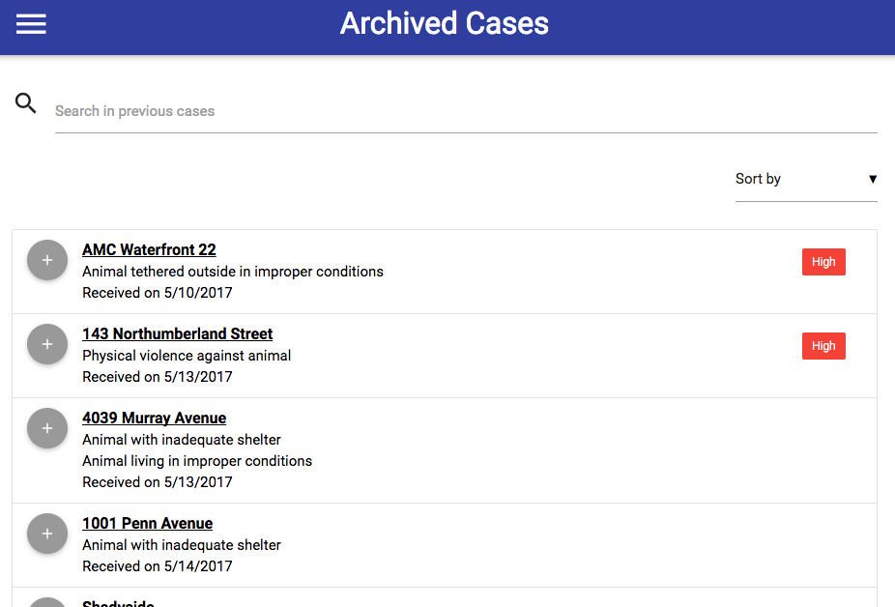

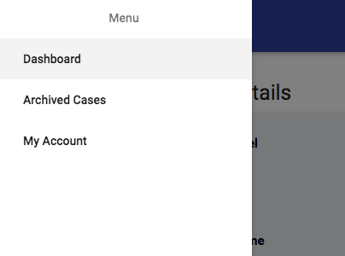

# Appendix

Final deliverables Google Drive folder - <https://drive.google.com/drive/folders/0B-qzOxOPx3VXNFlheklBa3J3SmM?usp=sharing>

## Technical Documentation

**Deployed website links**

* Humane officer dashboard - <https://tinyurl.com/animalcop-dashboard>
* Citizen reporting form - <https://tinyurl.com/animalcop-reporting>

**Technical implementation**

* Node.js
* All node modules used are included in the project code base (EJS, Express, Body Parser, etc.)
* Google Maps API
* MongoDB database hosted on mLab (<https://mlab.com/>)
* Website hosted on Zeit (<https://zeit.co/>)
  + Please contact Maggie Yu ([maggie9595@gmail.com](mailto:maggie9595@gmail.com)) if access is needed to any of the accounts above

**Features to be implemented in the future**

Most of the core functionality of the application has been implemented by the team and can be seen on the deployed version of the websites. In-line comments describing the existing features can be found in the code base.

The features included below were unimplemented due to the team’s time and resource constraints, but they are ones we think would be valuable to the application and Human Animal Rescue. Please note that some of the features already have a frontend and only require the backend functionality to be finished in the future.

Citizen reporting side

* Shelter buddy integration
* Ability to upload multiple images within the form
* Restrict form submissions to Pittsburgh region addresses only

Humane officer side

* Shelter Buddy integration
* Authentication/authorization system
* Sort by date, urgency, and proximity for new and in progress cases
* Search for archived cases
* Ability to view, edit, and add notes to each report
* Automatic email notification to the citizen reporter when a case status is changed to in progress/completed
* Optimize route based on current itinerary (via Google Maps)
* Save current itinerary order to database
* Automatic itinerary ranking to be suggested and reset by the system each day (potentially at 5AM)
  + Suggested ranking algorithm
    - Use the urgency and how many days have passed to calculate the first/most important case and add it to the itinerary
    - Then in order to find the other 4 cases for the itinerary, re-calculate the importance of every other case with urgency, how many days have passed, and distance from the first case and get the top 4 from this algorithm
  + Limit suggested itinerary to 5 cases only, but still allow the user to add more if they wish

Email Update Template

**Subject:** Animal Cruelty Report Update

"Hi [Reporter's Name],

Thank you for taking the time to report the case of animal cruelty or neglect. We are e-mailing to update you that the case has been investigated by our Humane Officer and we are working to reconcile the situation.

Best Regards,

Humane Animal Rescue